

End-of-Valley-Target site reporting

Exceedance curve data template – Instructions for use

13th September, 2022

# Resources:

Reporting resources include:

* EoVT site reporting exceedance curve template instructions (these instructions)
* Excel template tool for each reporting site
* Troubleshooting log
* Relevant BSM2030 procedures: *EoVT Reporting, Catchment Salinity, Modelling*

# Template tool overview



|  |  |
| --- | --- |
| Tab colour | Description |
| Green | Requires regular updates for each reporting period |
| Yellow | Recommended checking during each reporting period and/or may require updates depending on method for step 4 (see steps below) |
| Orange | Only requires updating where BMP exceedance curves are being refreshed, including percentiles of interest. Note all charts will need to be refreshed after making changes to these tabs |
| Grey | Background working tab. Recommended no changes made to ensure proper functioning |
| Unlocked cells | Look for unformatted cells to enter data. Protected sheets have been applied to avoid accidental changes, input cells are unformatted, indicating these cells are unlocked and ready for use. Other cells may be unlocked if required via Tools>Protection (note no password is required) |

# Regular reporting

## Step 1: Version control

|  |  |
| --- | --- |
| Tab | Instruction |
| **About** | Complete version control fields (left to right) and save a new version. Cross reference troubleshooting log fixes applied against version where relevant |

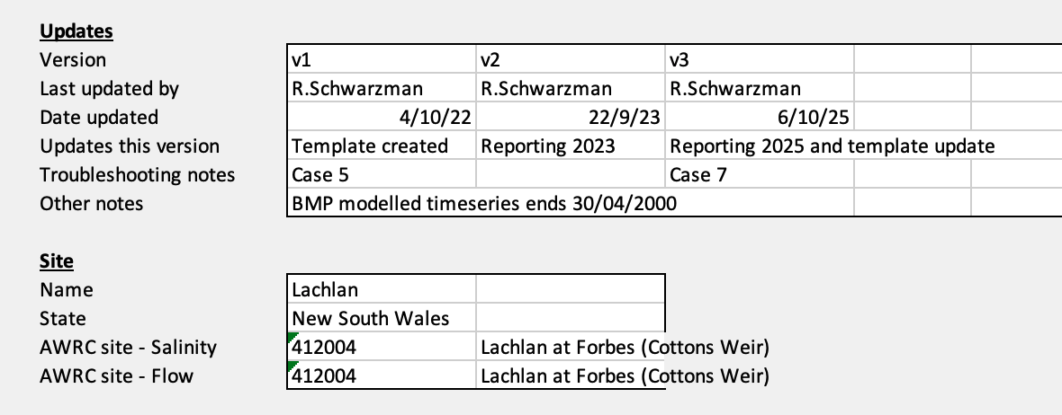

## Step 2: Add timeseries data

|  |  |
| --- | --- |
| Tab | Instruction |
| **Timeseries_Report** | * + Monitoring data timeseries should be cleaned outside of reporting template according to State protocols prior to entry.   + 0 EC data (and corresponding 0 t/day salt load data) has been cleared in templates (left as blank cell) to prevent skewing exceedance curves. EC data is also cleared where flows are 0 ML/day.   + Paste daily timeseries data for salinity (EC) and flow (ML/day) under existing data columns. Salt loads are automatically calculated in the template via the relevant conversion factor (see About tab).   + A summary of the record including rate of data gaps is provided at the top of the sheet for reporting and interpretation purposes.   + Check any filters are off to avoid overriding existing data and check date cell is entered in date format (not text or other).   + Note missing data (e.g., due to gaps in monitoring data) are permitted.   + Note data gaps at the end of a financial year (i.e. on 30th June) will affect the chart label for ‘Current reporting year’. Chart labels can be overridden manually where this problem occurs, integrity of exceedance curves will not be compromised. |

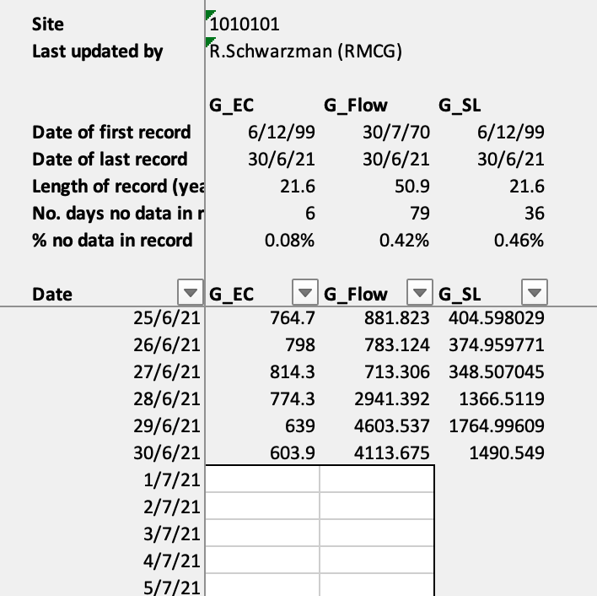

*Data is pasted against corresponding dates below historical entries*

## Step 3: Check data uploaded

|  |  |
| --- | --- |
| Tab | Instruction |
| **Output_Report_EC**  **Output_Report_SL** | * + Check new data has uploaded into relevant reporting year columns.   + Note new data will update percentile values for a number of overlapping reporting periods.   + The chart label "Current reporting period (RXXXX)" will show for the last reporting period with data complete up until 30/6 of the last year in the reporting period.   + Note if there is a data gap on 30th June for the last year of the reporting period, the label will not update automatically (see Step 2). Manual changes to the label should be made in the chart rather than the Output_Report_XX tabs   + Charts embedded in the Output-Report tabs should be updated with the current reporting periods of interest |

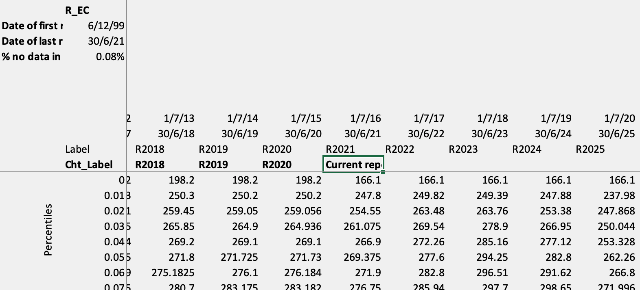

*Label is automatically generated for past reporting periods*

*Label is automatically generated for current reporting period if data is complete up to 30th June*

*If data is not yet complete for reporting period, no label is generated*

## Update charts

|  |  |
| --- | --- |
| Tab | Instruction |
| **Cht_Report_Exceed_EC**  **Cht_Report_Exceed_SL** | The following features require updating for each reporting period: |
| a) Three reporting period curves on each chart must be updated. This may be by:  i) updating series function in function bar (chart series must be selected to edit);  ii) editing series references in Select data source window; or  iii) updating chart embedded in Output_Report tab and copying and pasting into new BMP exceedance curve chart (chart type will need to be changed for upper and lower bound series to create block out). NOTE: if any changes are made to percentiles, the BMP block out curves should be updated in Cht_BMP_EC and _SL prior to being combined with reporting year curves via method iii) |
| b) Y Axis and legend may require refreshing |
| c) Titles, axis labels and percentile error bars should be checked for consistency |

*Check whether latest series is showing –*

*‘Current reporting period (RXXXX)’ should be displayed rather than RXXXX*

*Both Salinity (EC) and Salt loads (t/day) curves should be prepared for each site*

*BMP exceedance curves and percentiles should remain the same during regular reporting. If these features require updates, this should be done in the BMP tabs prior to combining with Report tabs*

*BMP curves are displayed using a ‘block out’ style. The order of the series can affect how these series display (line styles can be masked by block out curves). Use Change chart type to display BMP curves in block out style and Select data source window to change order of series if required*

## Reporting template updates and other notes

|  |  |  |
| --- | --- | --- |
| What | Tab | Instruction |
| Changing percentiles of interest | **Output_Report_EC**  **Output_Report_SL** | * + Percentile of interest may be changed in the Output_BMP_EC or _SL tabs.   + Verticle percentile bar will need to be updated in Output_BMP_EC or _SL tabs and Cht_BMP_Exceed_EC and _SL tabs. |
| **Cht_Report_Exceed_EC**  **Cht_Report_Exceed_SL** | * + Legend will need to be reset and Upper and Lower bounds for the BMP will need to be re-formatted in Cht_BMP_Exceed_EC and _SL tabs   + Using block out chart style - dark grey for upper bound, white for lower bound, NOTE: lower bound must be sequenced after upper bound in Select Data Source window   + Labels will automatically update to new bounds. |

|  |  |  |
| --- | --- | --- |
| What | Tab | Instruction |
| Updating BMP curves | **Timeseries_BMP** | * + Where BMP models are updated and generate new timeseries for BMP exceedance curves, datasets should be updated in the Timeseries_BMP tab. |
| **Cht_BMP_Exceed_EC**  **Cht_BMP_Exceed_SL** | * + Charts may also require updates (e.g. axis and upper / lower bounds) |

|  |  |  |
| --- | --- | --- |
| What | Tab | Instruction |
| Note on updating blockout curves: | **Cht_BMP_Exceed_EC**  **Cht_BMP_Exceed_SL** | If updates to the BMP curves are required, blockout curves will need to be updated.  This is done by  i) ensuring the lower bound is sequenced second last and upper bound sequenced third last (percentile of interest is sequenced last);  ii) selecting upper bound, changing chart type to 2D Area curve under Line charts, changing fill area colour to grey; and  iii) selecting lower bound, changing chart to 2D Area curve under Line chart, changing fill area colour to white |

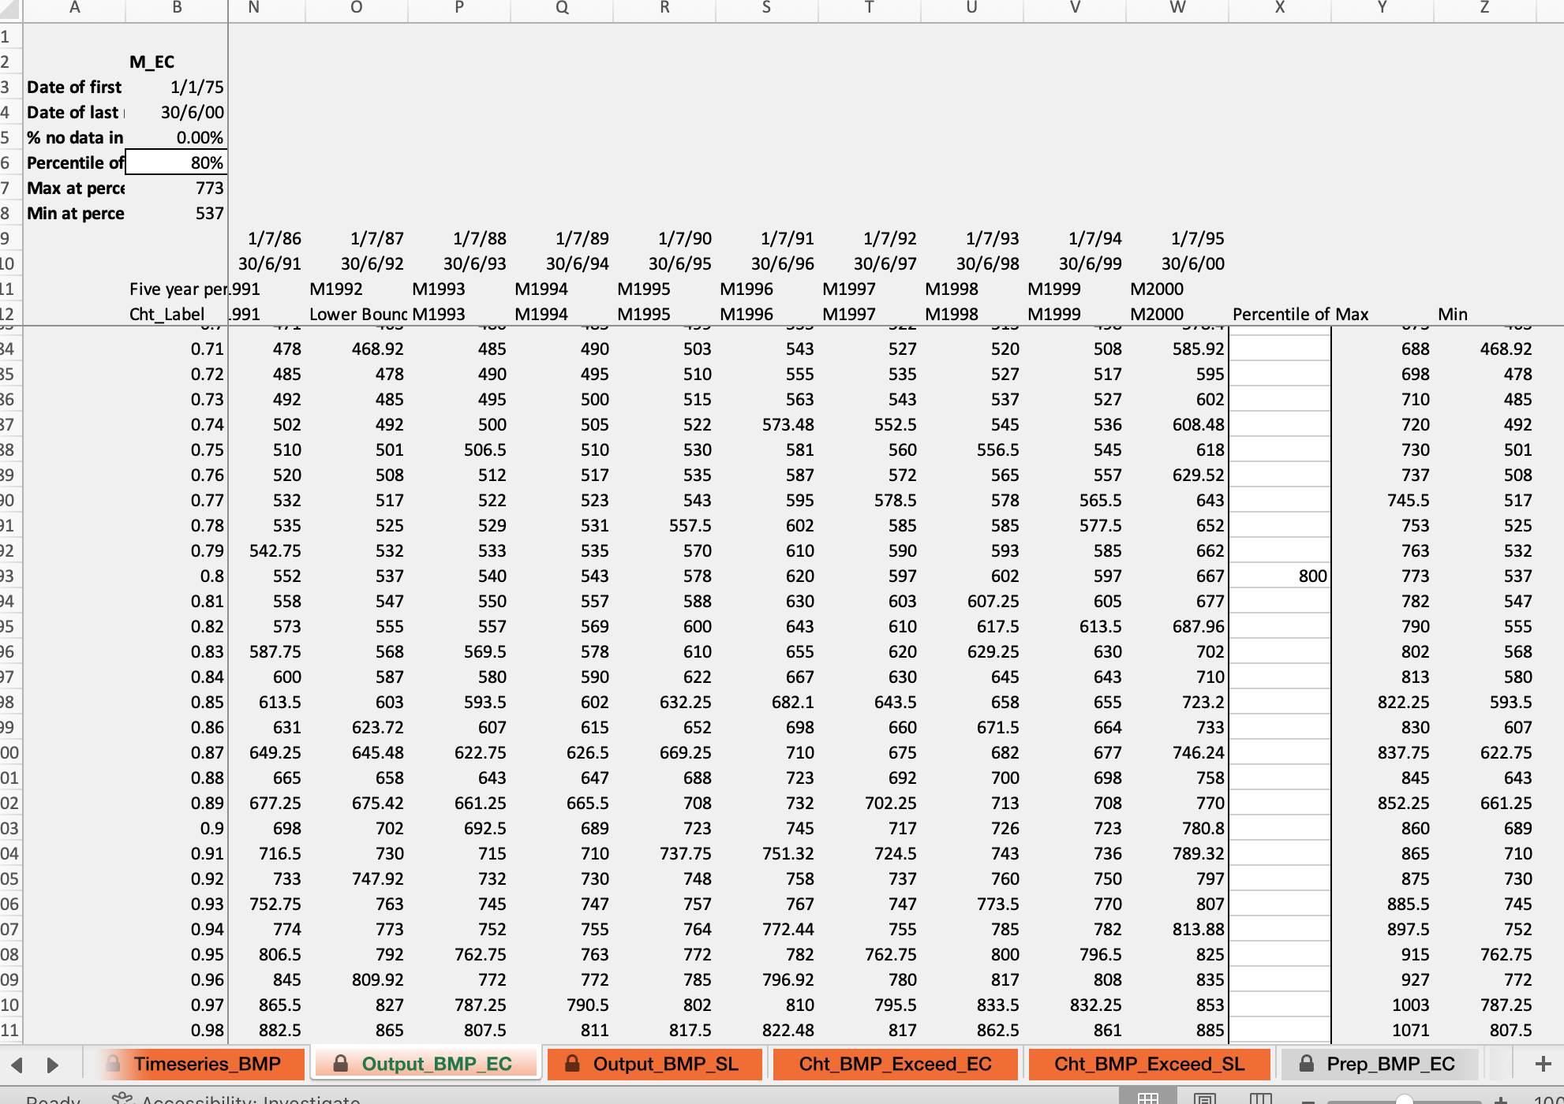

*Percentile of interest may be changed here*

*Changing percentile may change upper or lower bounds (label updates automatically)*

*Change percentile display on chart by manually entering ‘800’ against relevant percentile*

*Series displaying Upper or Lower Bound label should be formatted as block out style (use Change chart style – grey for upper, white for lower) and series should be ordered to ensure block out is displayed in background*

*Percentile display is updated via the Output_BMP_XX tab (column x – see instructions above)*

*When combining BMP and Report curves in Cht_Report_Exceed_XX, line series between upper and lower bounds should be omitted*

|  |  |
| --- | --- |
| What | Notes |
| Refreshing slow workbook | * + Some EoV sites have long timeseries back to as early as 1930s. This can cause the spreadsheet to be slow to operate.   + The reporting template can be split into historical reporting periods if needed to reduce the extent of the record and speed up operation. This can be done by duplicating the workbook and splitting the timeseries across the two workbooks.   + Alternatively, salinity (EC) and salt load (SL) tabs can be split into separate spreadsheets. The Timeseries tabs will need to be duplicated in both |
| Reporting other statistics | * + The **Output_Reporting tabs** display values for the full range of percentiles which may be of interest for a given reporting period (e.g. median, 95%ile etc)   + Timeseries data may be further manipulated as required to generate other statistics. HOWEVER it is recommended this should be undertaken in a separate workbook to avoid impacting the tool   + Statistics for salt loads in t/y may be calculated at the relevant percentile by multiplying value by 365 for comparison with historical data |

# Metadata and other notes

|  |  |  |  |
| --- | --- | --- | --- |
| Item | Source | Project | File name |
| Timeseries_BMP | Jacobs | VC00068 | 1010101_New_Template_v2_[1.0] |
| Timeseries_Report | MDBA | BSM EoV Monitoring | Data Tables 10_17_18_2019_21.xls |
| Conversion factor | MDBA | BSM EoV Monitoring | Data Tables 10_17_18_2019_21.xls |

|  |  |
| --- | --- |
| Item | Units and conventions |
| Flow | ML/day |
| Salinity (EC) | EC @ 25 (uS/cm) |
| Salt load (SL) | t/day |
| Reporting period | M refers to Benchmark Period 5Y periods (modelled data), R refers to reporting 5Y periods (monitoring data) |
| Chart and ouput labels are shown as the last year of any given BMP or reporting period (e.g. reporting period 1/7/2014 - 30/6/2019 will display R2019) |

|  |  |  |  |  |
| --- | --- | --- | --- | --- |
| STate | STation No. | River | Site | Conversion factor |
| NSW, Vic, SA, ACT | All other stations | | | 0.0006 |
| NSW | 416001 | Barwon | Mungindi | 0.00068 |
| NSW | 422015 | Culgoa | Brenda | 0.00074 |
| NSW | 422030 | Narran | Angledool | 0.00074 |
| NSW | 423004 | Warrego | Barringun | 0.00079 |
| NSW | 423005 | Cuttaburra | Turra | 0.00079 |
| QLD | 416202A | Weir | Talwood | 0.00068 |
| QLD | 416310A | Dumaresq | Farnbro | 0.00068 |
| QLD | 416415A | Macintyre | Booba Sands | 0.00068 |
| QLD | 417204A | Moonie | Fenton | 0.00081 |
| QLD | 422207A | Balonne | Ballandool | 0.00074 |
| QLD | 422209A | Balonne | Bohkara | 0.00074 |
| QLD | 422211A | Balonne | Briarie | 0.00074 |
| QLD | 422308C | Condamine | Chinchilla | 0.00074 |
| QLD | 424201A | Paroo | Caiwarro | 0.00071 |